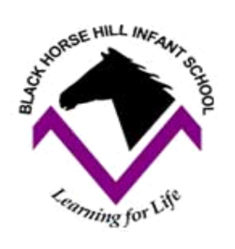
Year 1 Homework
Week ending 12/7/24

Dear parents/carers,

This is the last homework of school year! This week, we have focussed on our time in Year One and the children have written a recount of their favourite parts of the academic year. Some favourites have been our school trips, Design and Technology and Science.

In Maths this week, we have been learning about position and direction. We have furthered our understanding of lots of positional language, such as quarter turn, half turn, and whole turn, left, right, forwards, backwards, above and below. We have used a range of equipment to support this and played many different games in class to help our understanding further.

Thank you for your support throughout the year and hope you enjoyed the class assemblies! The children were amazing!

Enjoy the summer!

Mrs McLeod and Mr Hamm
Reminder!
Can all school books, which are at home please be returned to school ASAP. This is really important so they can be ready for the following school year. Thank you.

ACTIVITIES

- Practise the skills mentioned on your report.
- Keep reading as much as possible.

