Geography Implementation and curriculum progression

Geography Implementation and curriculum progression

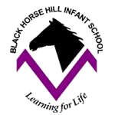
Geography Implementation and Progression at Black Horse Hill Infant School
Vocabulary and Reading Development | Inclusion | Assessment
Spoken language is promoted in all lessons for all children including strategies such as: no hands up , explicit teaching of vocabulary, modelled thinking and use of vocabulary by the teacher, think, pair, share, my turn-your turn, Talk Partners, Sentence Stems.  Reading is promoted wherever possible and wider texts are used to deepen knowledge across all subject areas. | All children will be given the same task because we believe in teaching a mastery approach across all subject areas and equal access for all.  Quality first teaching for all children  Teacher modelling and scaffolded practice for all children.  Focus groups with adult support for children needed further support  Pre-teach sessions  Talk partners to build confidence  Now and next boards to support completion of tasks  Intervention  External advice sought to support inclusion | Prior knowledge/retrieval opportunities are included at the beginning of units of work so that planning can be adapted/amended to support gaps or misconceptions.  Clear sequence of lessons which identify the key knowledge that children need to know at the end of a lesson/unit of work.  Children’s books  Knowledge Quizzes  Assessment tick sheets to identify cohort, group and individual gaps
Retrieval practice (Knowing more and remembering more) | Cultural Capital opportunities | British values and SMSC
Expectations for classroom working walls.  Revisit sessions  Retrieval/fluency sessions  Knowledge organisers published versions and class knowledge organisers | Enrichment - Gilroy Nature Reserve, Port Sunlight Village, Beeston castle, West Kirby, Knowsley Safari Park, Liverpool  Visitors – RNLI, florist.  School assemblies: Remembrance, Gun Powder plot  Significant places | Through teaching geography, we can also develop children’s development of SMSC and British values. Essentially, Geography is about studying people; where they live and our relationship with the environment This involves providing children with the opportunities to reflect on their own values and beliefs and those of others in our world. An essential component of Geography is place knowledge. By understanding the features and characteristics their local area, children understand why it is like that, and can contrast where they live with more distant localities, in this country and abroad. This understanding ensures children are aware of the cultural traditions associated with the place they are studying, as well as our own diverse society.  Children will also learn the need to respect and protect their local environment and the wider world.

Early Years Foundation Stage
Foundation 1 | Autumn 1 | Autumn 2 | Spring 1 | Spring 2 | Summer 1 | Summer 2
Project for the half term | Once upon a Time (Literacy)  Build it up (UoW) | Sparkle and shine (PSED) | Dangerous Dinosaurs (UoW) | Puddles and Rainbows (UoW)  Let’s Explore (UoW) | Creep, Crawl and Wriggle (UoW)  Animal Safari  (UoW) | Splash! (UoW)  On the beach (UoW)  Coast to Country Environmental project
Geographical Knowledge Linked to Development matters | Use story books to encourage children to comment about the features they notice on a character’s route. Model new vocabulary about simple human and physical features. (Traditional tales: Goldilocks; Little Red Riding Hood; Hansel and Gretel; Rapunzel; Three Little Pigs)  Using story books, non-fiction texts and photographs describe similar environments containing bridges and towers.  Follow a route to the post box.  Visit from the postman. | Know similarities and differences between different religious and cultural communities in this country and groups from around the world drawing on what has been read in class.  (Light festivals; Diwali; Christmas around the world)  . | Explore volcanos around the world.  Use a map to navigate a dinosaur hunt.  Features of school; playground; classroom; houses; road. |  | Explore the natural world by planning a route for a mini-beast hunt in school grounds.  Collect simple geographical data during a fieldwork activity (school Safari) discovering which animals and plants live on the school grounds. Take photos to discuss what was found back in the classroom. Discuss local environment habitats and hot and cold places. Set up bird feeders or bird baths in sheltered spots in school grounds. Record the birds that come and feed.  Identify which animals live in hot climates or cold climates. Identify some similarities and differences between life in this country and life in other countries, drawing on knowledge from stories, non-fiction texts and – when appropriate – maps.  Locate Africa and The Serengeti on a world map or globe. Compare animals found living wild in The Serengeti to animals living wild in their locality.  Identify animals found in Eileen Browne’s Handra series of books. The village is in south-west Kenya, Africa. Locate Kenya on world map or globe and show the location of the UK. Compare Handra’s life in an African Village to their own. | Identify aquatic animals living in the world’s oceans.  Discuss animals that live in a beach. Visit local beach and rock pools to collect ‘treasures’ using nets, scoops, tweezers, buckets and spades. Identify what was found on beach, e.g. pebbles, sand, seaweed, litter, driftwood, boats. Discuss animals seen or found, e.g. gulls. Identify what was found in rock pools, e.g. anemone, barnacle, crab.  After reading and discussing a range of books explore how and when people leave litter on beaches and how this can harm wildlife in our seas and all around us.  Use a treasure map to look for treasure hidden in nursery provision (indoor and outdoor). Follow directions as they search for treasure. Draw own treasure maps and give directions to peers.  Discuss ways to take care of the wider and local environment and how to protect and care for animals, ,e.g. litter can be harmful to animals that live in school grounds. Conduct a school litter pick.
Experience, knowledge and skills.  Understanding the World | Draw information from a simple map.  Explore and discuss similarities between environments. With support, observe, record and talk about different materials suitable to make a physical feature (bridge; tower; wall; house).  Know that objects can represent other things when involved in block play/construction. | Show and an awareness of the similarities and differences between people in different communities and groups from around the world. Talk about the use and symbolism of light festivals around the world at different times of the year.  Describe how places celebrate Christmas the same or differently using simple picture maps, photographs, data and other geographical resources.  Talk about how people around the world celebrate Diwali and discuss traditions. Develop positive attitudes about the differences between people. | Follow a simple map to find dinosaurs. | Begin to understand the effect of changing seasons and weather patterns.  Describe natural phenomena such as the speed of clouds moving across the sky.  Observe changes in the weather and seasonal changes, e.g winter.  Talk about what the children see using a wide range of vocabulary while exploring rainbows. | Conduct a mini-beast hunt searching the school grounds, using a simple map, exploring areas where children have never been e.g. wooded area.  Conduct a school safari describing the immediate environment using knowledge from observation, discussion, stories, non-fiction texts and maps.  Identify animals found in Eileen Browne’s Handra series of books. The village is in south-west Kenya on world map or globe. Show the location of the UK. Compare to Handra’s life in an African village to their own.  Begin to notice and talk about the different places around the world, including oceans and seas.  Describe how two places are the same or different using simple picture maps, photographs, data and other geographical resources, e.g. non-fiction texts. Describe a contrasting environment to their own.  Talk about simple differences between the way people live in their community and beyond (village in South-West Kenya) using pictures, books, maps and other geographical resources, e.g. non-fiction texts. | Begin to collect simple geographical data during fieldwork activity, e.g. visit to local beach.  Show care for living things and the environment.  Understand a map is a drawing that shows an area of land or sea. A map shows natural physical features such as mountains and rivers, and man-made features, such as roads and houses. Describe a familiar route and use maps as part of role-play.
Key Vocabulary | Route, map, trees, forest, house, cottage, woods, pathway, bridge, different, same, places, river, tower, wall | Cultures, communities, festivals, traditions, countries. | Travel, map, direction, forward back, side, left, right, swamp, volcano, ammoniate, forest, island (physical features). | West Kirby; school; map; road; house; playground; rainbow; raindrop; sunny; cloudy; rainy; snowy; windy, weather, symbols, rain cloud, water droplets, heavy, rain, | Kenya, map; route; mini-beast | World, oceans, seas, marine animals, globe, maps, beach, shoreline, features, coastline, coast, sea; globe; seashore; land.
Wider Texts | 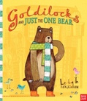  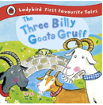  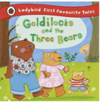  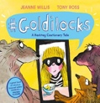  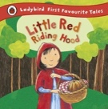  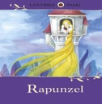  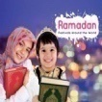  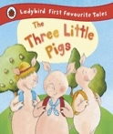  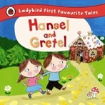  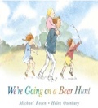  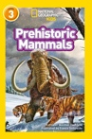  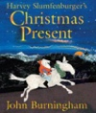  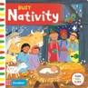  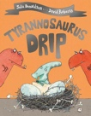  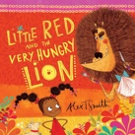  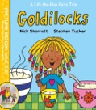  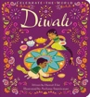  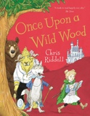  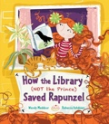  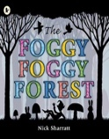  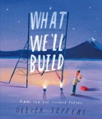 | 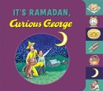  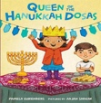  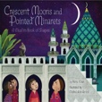  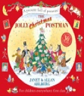  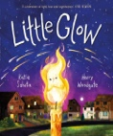 | 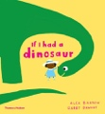  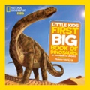  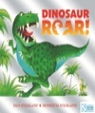  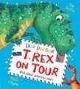  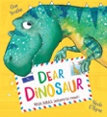  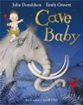 | 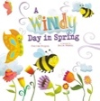  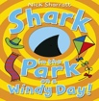  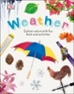  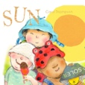  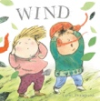 | 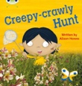  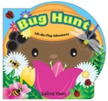  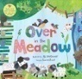  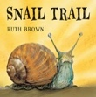  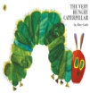  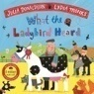  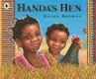  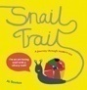  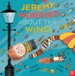  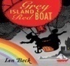  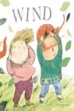  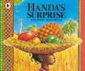  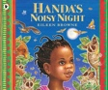  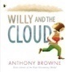  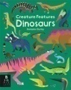  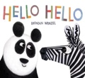  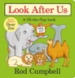 | 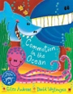  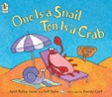  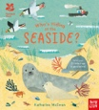  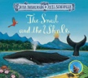  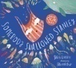  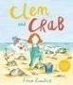  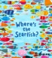  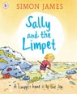  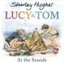  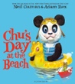  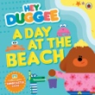  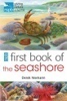  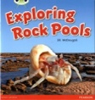
Cross Curricular links | UW - The natural world – sorting and grouping materials and resources to build a house for The Three Little Pigs. Physical development – Gross motor – using a variety of resources make a path across a river. PSED – Self Regulation – show an understanding of their feelings and those of others. EAD – Creating with materials – make simple structures using a range of materials. EAD – Creating with materials – develop own ideas and explore with a range of resources to create ‘small worlds.’ Literacy – Comprehension - Demonstrate understanding of what has been read to them by retelling stories and narratives using their own words and recently introduced vocabulary. | Literacy – Comprehension – use and understand recently introduced vocabulary during discussions about stories, non-fiction texts and picture cards. EAD – Creating with materials – explore ways of changing the shape or texture of malleable materials when making diva lamps. | UW – the natural world | UW – breadth – use technology to record ideas and work. | UW – create simple programs. UW – the natural world – explore the natural world around them, making observations and drawing pictures of animals and plants. Know that a habitat is a place where living things live in the local environment. Literacy – Comprehension – use and understand recently introduced vocabulary. CLL – attention, listening and understanding – hold conversation when engaged in back-and-forth exchanges with adults or peers. | CLL – listening, attention and understanding – express ideas and feelings about experiences using full sentences including use of past, present and future tenses and making use of conjunctions, with modelling and support from adults.

Foundation 2 | Autumn 1 | Autumn 2 | Spring 1 | Spring 2 | Summer 1 | Summer 2
Topic for the half term | Me and My Community (PSED) | Exploring Autumn (UoW) | Winter Wonderland (UoW) | Starry Night (UoW)  Signs of Spring (UoW) | Sunshine and Sunflowers (UoW) | Big Wide World (UoW)
Geographical Knowledge Linked to Development matters | Describe immediate environment using knowledge from observation, discussion, non-fiction texts and maps. Walk around school and explore the school community. Meet people from school community, e.g. police officer; fire fighter; RNLI; paramedic  Explore aerial pictures and photographs of West Kirby. Draw messy maps of a journey to school or a local place of interest for example St Michael’s Church) | Know ways to care for their local outdoor environment by using rakes, brushes, buckets and bin bags. Talk about natural changes that happen during the season of autumn, including how the weather changes, and why trees lose their leaves and how wild animals prepare for winter. | Talk about similarities of animals from the Arctic and the Antarctic. Use vocabulary related to natural physical features, e.g. Mount Everest, mountain. Use vocabulary related to changes in natural world, e.g. seasons, winter, icy, weather.  Discuss what is seen in winter photographs and talk about changes in weather since start of school year. Recap different seasons and the weather and day length changes during the year. Walk around school grounds on a cold and frosty day taking photos on ipad to record evidence. Collect photos from home and discuss why they are wearing warm clothing. | Know some similarities and differences between different religious and cultural communities in this country, drawing on their experiences and what has been read or watched in class, e.g Easter traditions and Christian community; Diwali and Hinduism.  Understand some important processes and changes in the natural world around them, including the seasons and changing states of matter. Walk around school grounds looking for signs of spring and take photographs | Describe local environment using knowledge from observation, discussion, photographs, non-fiction texts and maps. Map a photographic map and use positional language to describe where each park / garden area should go. | Describe their immediate environment using knowledge from observation, discussion, stories, non-fiction texts, maps and videos.  From a collection of postcards sent from around the world (children and staff bring these in or make them up) identify their location on a world map and that of the UK (on a UK map). Look at both sides and discuss the things people wrie about e.g. physical features, man-made features, weather, season.  Talk about the journey and use positional language and describe features, e.g. traffic lights, zebra crossing.  Explain some similarities and differences between life in this country and life in other countries, drawing on knowledge from stories, non-fiction texts and – when appropriate – maps. Discuss places shown in a ‘Wish you were here’ video: Eiffel Tower, Paris, France, Statue of Liberty, New York, Sydney Harbour bridge, Sydney, Australia, London Eye, London, England, Pyramids, Giza, South Africa, Sahara Desert, North Africa, Antarctic. Discuss places children have visited on holiday or lived in. Use holiday brochures and photographs. And ‘Big Wide World’ video discuss land and water, continents and oceans.  Discuss UK has four countries, weather and seasons and other countries children have visited. ‘World Climate Map’ talk about the different land colours. Discuss what parts of the world have hot and humid climates and cold and dry climates.  Explain some similarities and differences between life in this country and life in other countries, drawing on knowledge from stories, non-fiction texts ‘Our world: A First Book of Geography.’ Discuss where different habitats are in the world (book opens into a globe) and the weather.  Explain some similarities and differences between life in this country and life in other countries, drawing on knowledge from story books ‘All Are Welcome.’ Explore how the children in the story might have a different heritage from each other but are united in their play and friendship. Explore how the word ‘diversity’ is used and how everyone in the story is unique and special. After looking at ‘Food around the world’ picture cards discuss location on map. Compare food they like to eat home to that shown in cards. Provide a selection of ’food from around the world.’ Describe ‘Buildings around the world’ and how people might use them. Locate on world map or globe. Use Google Earth to search for significant buildings and landmarks. Discuss natural features found in the largest savannah in Africa. Locate on world map. Read ‘Under the same sky’s story book and look at ‘Our World picture cards.’ Compare how their environment is similar or different to the environments shown in the picture cards.
Experience, knowledge and skills.  Understanding the World | Take photographs, draw simple picture maps and collect simple data during fieldwork activities, e.g. walk around the school. Understand that fieldwork includes going on walks and visits to collect information about the school environment. Know that a community is a group of people who share or live in the same place and communities differ. Show an understanding of the meanings of new words by using them in discussion and role-play situations.  Name and talk about man-made features in the local environment. Make and use simple maps in their play to represent places and journeys, real and imagined. Know a map is a picture or drawing of an area of land or sea. | Know that litter has a harmful effect on the areas where we live, work and play. Describe how they can look after their outdoor provision. | Describe how two places are the same or different (Arctic and Antarctic – cold places) using simple picture maps, photographs, data and other geographical resources. Know different places have different climates and weather.  Identify the four seasons in the UK and how each season has typical weather associated with it, including rain, sun, wind and snow. Understand the difference in day length in summer and winter. | Show an awareness of the similarities and differences between people in different communities and groups from around the world, e.g. Easter traditions and Christian community; Holi and Hindu community.  Know spring is one of the four season and follow winter. Identify changes in local environment and changes in different seasons. | Know a map is a picture or drawing of an area of land or sea. Make simple maps to represent places. | Take photographs, draw simple picture maps and collect simple data.  Begin to notice and talk about the different places around the world, including oceans and seas. Know that globes and maps can show the location of different places around the world.  Show an awareness of the similarities and differences between people in different communities and groups from around the world. Know that heritage is a person’s unique, inherited sense of family identity, including traditions and culture. Some families define their heritage as their ethnic, cultural or national identity.  Know that a map is a picture of an area of land or sea. Make and use simple maps for positioning world vehicles.  Know that a globe is a 3D model of the Earth and maps show 2D images of places. Describe how weather differs from one place to another using simple geographical terms.  Know climate and environments are different depending on their location on Earth, e.g world climate map.  Locate countries on world map or globe of food from around the world.  Know places have different climates, weather, culture and amentities. Know a savannah is a mixed grass and woodland habitat and is the world’s largest savannah is in Africa.
Key Vocabulary | Maps, community, information, local environment, same, different, shops, church, street, road, houses, aerial photographs, landmarks, labels, route, direction, forward, backward, near, far, grid, travel. | Outdoor, litter, harmful effects, environment, weather, changes, winter, season, autumn. | World map, globe, Arctic, Antarctic, mountain, cold places, hot places, weather, climate, natural, , mountains, seas, oceans, seasons, Spring, Summer, Autumn, Winter, United Kingdom, weather, icy, days climate, snowy, North Pole, warm, coldest, South Pole,. | Similar, different, cultures, communities, traditions, festivals, Easter, Christian community, Holi, festival of colour, Hindu community, India, world map, globe, season, spring, | Maps, land, sea, locality, environment, park, garden, man-made features, route, trail, physical features, man-made features, direction, forwards, backwards, turn, near, far. | Journey, route, plan, map, e.g. railway station, world map, globe, United Kingdom, countries around the world, physical features, weather, season, heritage, traditions, culture, position, direction, forward, backward, near, far, ,  Google Earth, landmarks, significant buildings, savannah, trees, grass,
Wider Texts | 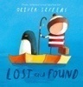  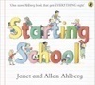  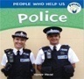  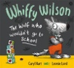  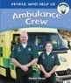  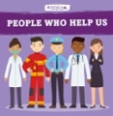 | 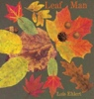  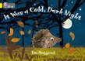  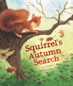  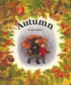  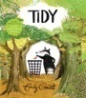  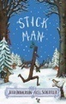 | 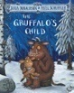  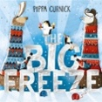  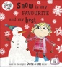  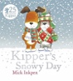  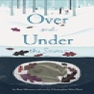  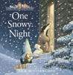  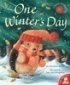  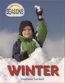  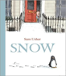  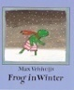  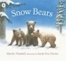  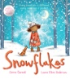  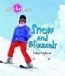  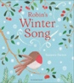  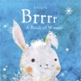  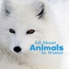 | 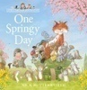  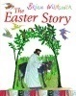  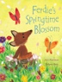  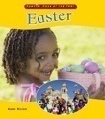  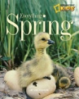  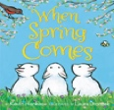 | 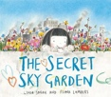  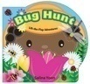  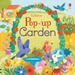  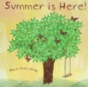 | 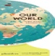  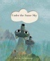  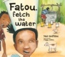  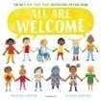  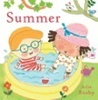  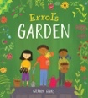  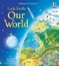  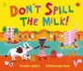  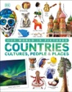  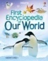  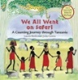  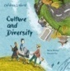  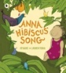  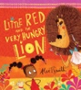  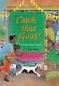  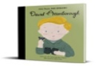  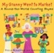  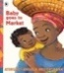  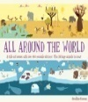  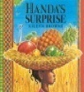
Cross Curricular links | Literacy – Comprehension – use and understand recently introduced vocabulary. CLL – attention, listening and understanding – hold conversation when engaged in back-and-forth exchanges with adults or peers. UW – input simple directions (instructions) to technological toys. | Literacy – Comprehension – use and understand recently introduced vocabulary. UW – the natural world – understand some important processes and changes in the natural world around them, including seasons and changing states of matter. | Literacy – Comprehension – use and understand recently introduced vocabulary. UW – the natural world – understand some important processes and changes in the natural world around them, including seasons and changing states of matter | Literacy – Comprehension – use and understand recently introduced vocabulary. EAD – creating with materials – safely use and explore a variety of materials, tools and techniques, experimenting with colour, design, texture, form and function. | UW – input simple directions (instructions) to technological toys. | EAD – creating with materials – safely use and explore a variety of materials, tools and techniques, experimenting with colour, design, texture, form and function – know a painting of a place is called a landscape. Draw or paint a place from observation. CLL – Listening, attention and understanding – listen attentively and respond to what they hear with relevant questions, comments and actions. EAD –  Explore and create using a wide range of materials and components.

KS1
Year 1 | Autumn 1 | Autumn 2 | Spring 1 |  | Spring 2 | Summer 1 | Summer 2
Topic for the half term | Childhood (History) | Bright Lights, Big City (Geography) | School days  (History) |  | Weather Watchers  (Geography) | Moon Zoom  (History) | Where are we in the World?
Experience, knowledge and skills.  Locational knowledge |  | To be able to find and locate West Kirby/Wirral on a UK map.  The Wirral is a peninsula. Our school is in West Kirby.  Know school address including road, town, country and postcode.  Know that the UK is a union of four countries, each with a capital city. Locate each capital city on a map and name the seas that surround the UK. | Revisit the location of the school as part of this learning. | To be able to find and locate West Kirby /Wirral on a UK map and on  Know that the UK is a union of four countries, each with a capital city. Locate each capital city on a map and name the seas that surround the UK.  To know where the equator is on the world map. |  |  | To be able to find and locate West Kirby/Wirral on a UK map and on a world map.  Name and locate the world’s seven continents and five oceans.
Experience, knowledge and skills.  Place  knowledge |  | To know that a settlement is a place where people live and work and can be big or small depending on how many people live there.  To know that Liverpool is a city.  To know that the names of River Mersey and River Dee.  To know some of the landmarks found in Liverpool.  To identify similarities and differences between London and Liverpool.  (Non-European Country) |  | Warmer areas of the world are closer to the equator and colder areas of the world are further from the equator. The equator is an imaginary line that divides the Earth into two parts: the Northern and Southern Hemispheres.
Experience, knowledge and skills.  Human and physical geography | Using 1950s map and also a present-day map, describe how a place and geographical features has changed over time. | To understand geographical similarities and differences through studying a small area of the UK (School locality)  Use aerial photographs and a variety of maps and plans of the school locality, Wirral and Liverpool to identify and use geographical vocabulary related to human and physical features. |  | Identify patterns in daily and seasonal weather using a ‘weather watcher.’ Collect rainfall in gauges and use measuring equipment such as tape measure and thermometer.  Know that there are four seasons and each has typical weather patterns. Know that the length of a day in the UK varies depending on the season. Discuss the consequences of extreme weather types.
Experience, knowledge and skills.  Geographical skills and fieldwork |  | Trip to Liverpool  To understand the concept of an aerial view by creating an aerial map of the classroom.  Carry out fieldwork tasks, including map work and observation, to gain a better understanding of the characteristics of the school, its grounds and the local environment. Explore satellite images of school and identify features. Tour school grounds and draw a labelled sketch map.  Understand a map is a picture or drawing of an area of land or sea. Using aerial photographs and identify landmarks of basic human and physical features in local area. Walk around local area and add labels of physical and human features on a map. Draw a simple map of the local area and construct basic symbols in a key.  Recognise features in a series of aerial photographs and draw simple sketch map of an aerial view of school grounds. |  | Use world maps, atlases and globes to identify the UK. and it countries |  |  | Use simple compass points and locational and directional language.
Key Vocabulary | Human and physical features, map, route, landmarks, West Kirby, Wirral, peninsula, Merseyside, town, postcode, road, aerial photographs, satellite image, locality, key, symbols, North West England, England, Wales, Scotland, Ireland, United Kingdom, city, town, settlement |  | Wirral, West Kirby, peninsulaUnited Kingdom, England, Wales, Scotland, Northern Ireland, weather, seasons (Autumn Spring, Summer, Winter, weather patterns, Northern Hemisphere, Southern Hemisphere, equator, globe, atlas, hot, cold, North Pole, South Pole, Antarctica, |  |  | Map, globe, atlas, compass points, north, south, east, west, countries, continents, land, sea, Asia, Europe, North America, Africa, Antartica, South America, North America, Oceania, Oceans, Atlantic pacific, Indian Artic, Southern, direction, forwards, backwards, left, right north, south, east, west.
Wider Texts to develop breadth of knowledge | 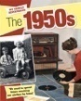 | 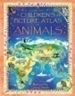  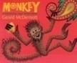 | 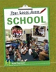  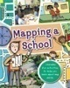  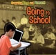  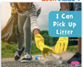  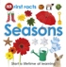  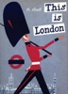  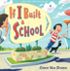  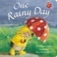  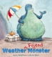  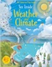  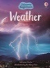  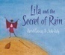  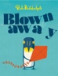  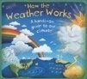  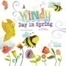  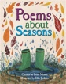 |  | 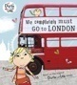  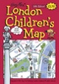  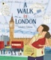  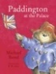 | 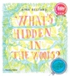  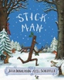  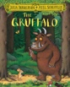  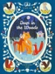 | 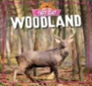  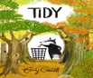
Cross Curricular links | History – learn about everyday life and families today, including comparisons with childhood in the 1950s, using artefacts and a range of different sources.  Maths |  | History – learning about their own school and locality, both today and in the past. Comparing schooling in the Victorian era to their experiences today.  Science – observe changes across the four seasons. Observed and describe weather associated with the seasons and how the day length varies. |  | Art-James Rizi Liverpool Landscapes. |  | Maths- position and direction.

Year 2 | Autumn 1 | Autumn 2 | Spring 1 | Spring 2 | Summer 1 | Summer 2
Topic for the half term | Street Detectives  (Geography) | Movers and Shakers (History) | Let’s Explore the World (Geography) | Magnificent Monarchs (History) | Magnificent Monarchs (History) | Coastline (Geography)
Experience, knowledge and skills.  Locational knowledge. |  | Know that Christopher Columbus was a significant explorer who started a time of exploration that lasted centuries. Name and locate the continents of Europe, Asia, and the Americas. Name and locate India, China and Japan (Indies). Name and locate Spain and Portugal. Name and locate the Atlantic Ocean and Indian Ocean. | Name and locate the world’s seven continents and oceans.  Know there are five oceans.  Know that the UK is an island surrounded by seas. Name and locate the Irish Sea, North Sea, Atlantic Ocean, Celtic Sea and English Channel.  Name, locate and identify characteristics of the four countries of the UK, e.g. population, cities, climate and weather, physical and human features.  Identify and locate: West Kirby, England, UK, Europe and Modgadishu, Somalia, Africa. |  | From visiting Beeston castle children will be able to see the areas of Wirral and Cheshire to support their locational knowledge of the area. | Name and locate the world’s seven continents and oceans.
Experience, knowledge and skills.  Place knowledge. |  | Understand the significance of place that is important to a local community because of the historical events that have happened near this location (Port Sunlight). | Describe and compare the human and physical similarities and differences between an area of the UK (West Kirby) and a small area in a contrasting non-European country (Modgadishu, Somalia). | .
Experience, knowledge and skills.  Human and physical features. | Understand the processes that give rise to key physical and human geographical features of the world, how these are interdependent and how they bring about spatial variation and change over time.  Use basic geographical vocabulary to refer to key human features, including: city, town, village, factory, farm, house, office, port, harbour and shop. | Define human and physical characteristics of a place e,g. War Memorial Monument, Lady Lever Art Gallery. | Know that the equator is an imaginary line that divides the world into hemispheres and the poles are the most northern or southern points on the earth. Locate the equator, poles and hemispheres.  Know places close to the equator have hot climates and places further away have cold climates. Know that temperate places are between hot and cold places.  Identify seasonal changes and weather patterns in West Kirby, England in relation to a hot place, Modgadishu, Somalia and its relation to the Equator. |  |  | Classify human and physical features found near coastlines.  Read a key and identify human and physical features of West Kirby coastline.  Understand that erosion is the physical process that involves the weathering and movement of natural materials, e.g. rock, sand. It is caused by wind and water.  Understand that physical features (sand dunes) and human features (house building; transport; entertainment) can change over time.  Understand that the land near West Kirby coastline is used for recreational, transport, residential and commercial purposes. Understand that tourism is an industry that provides services for visitors.  Understand that some weather patterns affect coastlines and coastal rescues.
Experience, knowledge and skills.  Geographical skills and fieldwork. | Use aerial photographs to describe features and characteristics of an area of land.  A map is a picture or drawing of an area of land that can show human and physical features.  Maps use a symbol and a key.  Know through fieldwork that an environment can change over time due to a geographical process such as erosion or human activity.  Use geographical vocabulary to talk about how a place has changed over time.  Ask and answer simple geographical questions about the local environment through observation and simple data collection. | Trip to Port Sunlight  Name, locate and identify Port Sunlight on a map. Use first-hand experiences to a significant place in their locality.  Use world maps, atlases and globes to identify countries, continents and oceans when learning about significant explorers.  Use world maps, atlases or globes to locate where significant individuals lived, e.g. Rosa Parks, USA. | Using an atlas name and locate continents and countries. Know an atlas is a book of maps and charts. Use simple compass points to locate countries, e.g. is Norway in Northern or Southern Europe.  Use a world map to name and locate the equator, poles and hemispheres. |  | Trip to Beeston Castle | Through Coast to Country project know that conservation is the protection of living things and the environment from damage caused by human activity. Understand conservation activities include reducing, reusing and recycling plastic. Know conservation activities protect the environment for people in the future.  Classify physical and human features found on coastlines into groups. Ask geographical questions through observation of photographs.  To know that the four cardinal points on a compass are north, south, east and west.  Use simple compass directions and locational and directional language to describe the location of coastlines on a map.  Know that maps use symbols and a key. A key is the information needed to read a map and a symbol is a picture or icon used to show a geographical feature. Locate symbols on coastal map of West Kirby.  Trip to West Kirby  To know that fieldwork can help to answer questions about the local environment and can include observing or measuring, identifying or classifying and recording.
Key Vocabulary | Aerial image, map, physical and human features, symbols, key. Local area, West Kirby, changes, survey, data, community. | Map, symbols, key, human and physical features, locality, monument, Lady Lever Art Gallery, museum, significant place and person, globe, world, continents, countries, oceans, seas. | Map, atlas, globe, compass points, north, south, east, west, southern, northern, country, cities, continents Eurpoe, Asia, North America, South America, Africa, Asia oceans, seas, direction, route, human and physical features, equator, North Pole, South Pole, Northern Hemisphere, Southern Hemisphere, weather, hot, cold, temperate, climate, natural resources, sustainability, local and global environment, population, cities, |  |  | Continents, Oceans (and names of), UK countries and capital cities, Compass points, conservation, sustainability, pollution, natural resources, local and global environments, natural, physical features, weathering, sand, coastline, erosion, man-made, human features, changes, differences, similarities, tourism, River Dee, RNLI, lifeboat stations, rescues.
Wider Texts to develop breadth of knowledge |  | 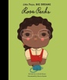  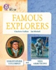  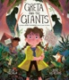  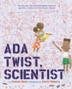  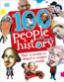  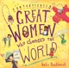 | 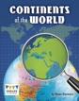  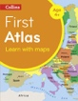  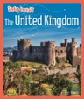  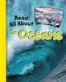  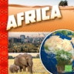  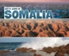 | 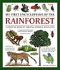  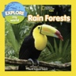  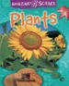  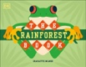 | 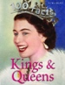  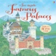  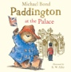  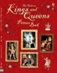 | 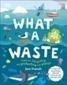  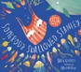  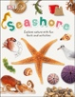  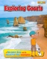  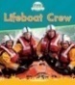
Cross Curricular links | Science – observe closely, using simple equipment to take measurements, observations and collect data.  Maths - statistics – interpret and construct simple tables. | History – learn about significant historical events, people and places in their own locality, e.g. William Lever.  History – learn about the lives of significant individuals in the past who have contributed to national and international achievements e,g Christopher Columbus | Science - observe and understand seasonal seasonal changes. | Maths - statistics – interpret and construct simple tables.  History – learn about significant historical events, people and places.  Visit to Beeston Castle | History – learn about significant historical events, people and places.  Visit to Beeston Castle | Science - observe seasonal changes.  History – Changes within living memory.

Geography Lesson Structure
Long Term Memory (Retrieval)
Review and revisit previous knowledge-make links to knowledge from previous lesson, unit, term, year.
Amend future planning to incorporate and gaps in knowledge.

