**Year 1 Homework**

**Week ending 24th November**

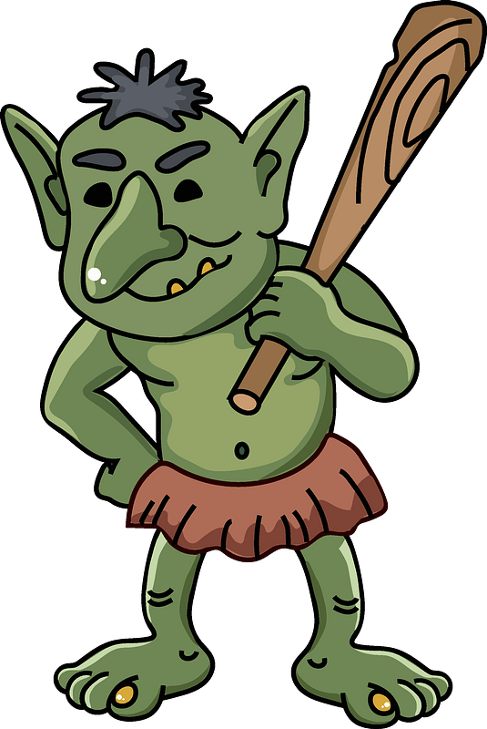

Dear Parents and Carers,

This week in English, we have received a note from Rapunzel on her travels. She has explained to us how she has met a mean troll. She has written a set of instructions for how to catch a troll and asked us to write a set of instructions to catch a witch. We have introduced the children to what a set of instructions are. We have also explained what imperative (bossy) verbs are and how they can be used in instruction writing. For example, cut, chop, push etc.

In Maths this week, we have begun our learning of subtraction. We began this by building off the children’s prior knowledge of parts and wholes. We used a range of concrete manipulatives to allow the children to find a missing part of a whole. We then applied this by solving problems and practising our reasoning skills. We have also introduced the children to the subtraction symbol and the range of language that can be used for this symbol (minus, subtract, take away etc.)

Thank you for your support,

Mrs McLeod and Mr Hamm

**ACTIVITIES**

1. Reading – Read your Big Cat Little Wandle book or your Reading for Pleasure book.
2. English – Chat Challenge! Use some ‘bossy’ verbs in a sentence. E.g. **Chop** the banana into pieces.

mix hold push chop cut grab put take use stir

1. Maths – Practise counting forwards and backwards from a range of different numbers.

CHALLENGE! Complete the missing number tracks.

