**Year 1 Homework**

**Week ending 5.7.24**

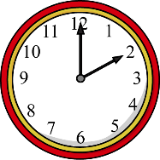

Dear Parents and Carers,

This week in English, the children have written their very own instructions for making a ‘Forest Flapjack’ for our characters from The Last Wolf by Mini Grey. They have used bossy (imperative) verbs when giving these instructions such as chop, place and mix. Everyone has worked so hard and the recipes are fantastic!

In Maths, we have continued our learning regarding time. We have been looking at telling the time to the hour (o’clock) and half past the hour (half past)on a clock. The children have also been learning about the minute (longer) and hour (shorter) hand on a clock. The children have drawn the hands onto clocks to tell the time.

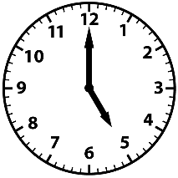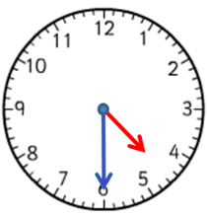

Thank you for your support,

Mrs McLeod and Mr Hamm

**PLEASE NOTE!**

Both classes have their school assemblies next week. Please bring in your child’s clothes for the performance by **Monday 8th July**.

Children should also continue to practise their lines with a loud clear voice.

ACTIVITIES

**Reading** – Read your Big Cat Little Wandle book and Reading for Pleasure book.

**Maths** – Play the time game attached with a sibling or grown up! Remember to look at the time carefully. Roll a dice and say the time on the clock! First to the end wins!

**English –** CHAT CHALLENGE! Tell a grown-up at home things you have enjoyed throughout Year One. For example, learning about our schools history or animals in Science.

