Year 1 Homework
Week ending 22.3.24

Dear Parents and Carers,

This week in English, the children have written a story similar to Where the Wild Things Are. The children have worked hard to ensure they have used capital letters, finger spaces, full stops as well the rich vocabulary they have been introduced to. We have also encouraged the children to take responsibility for checking their work by using the sentence checker (attached below) to ensure their sentences were punctuated correctly and made sense.

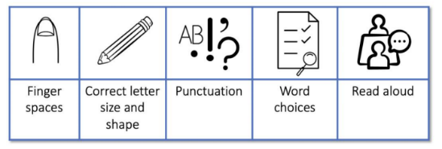

In Maths, We have explored weight, mass and volume this week introducing the children to the language heavier and lighter allowing them to compare the weight of two objects. We solved a range of problems related to weight, mass, volume and capacity.

As part of our Design and Technology, the children created their own woodland homes using a variety of different materials found in nature and cardboard structures.

Thank you for your support,
Mr Hamm and Mrs McLeod

ACTIVITIES

Reading – Read your Bug Club active learn book, reading book from school or your reading for pleasure book.

Maths – Visit Mathletics and login using the details inside your homework book. Click explore and select ‘Length, Mass and Volume’. Select ‘Everyday Mass’ and complete the questions!

English – Play the ‘-ed’ suffix game attached! Once you complete the game pick three of the words you have changed and use them in a sentence. Don’t forget to use a capital letter and a full stop!

