Year 1 Homework
Week ending 26/4/24
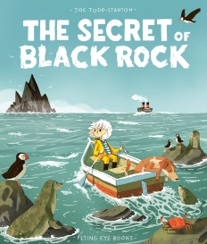

Dear Parents and Carers,

In English, we have begun writing a return narrative based on the book we have been studying called ‘The Secret of Black Rock’. We have used the language that we have learnt about over the course of the last few weeks as well as a range of adjectives to create a very descriptive piece of writing to start our stories. Whilst writing we have been rereading our work to check it makes sense whilst ensuring we have consistency with our use of full stops.

In Maths, we have been focussing on counting forwards and backwards in 2s, 5s and 10s. The children have been focussing on the multiples of these numbers up to and beyond 50! The children have completed various activities to improve their fluency and we have developed our reasoning skills by solving problems.

Thank you for your support,

Mrs McLeod and Mr Hamm

ACTIVITIES

- Reading – Read your Big Cat Little Wandle book and Reading for Pleasure book.
- Maths – If you haven’t already download the free app called ‘Whiterose One Minute Maths’. This is available on the app store when using apple products or if using android this is available via Google Play. Upon opening the app select ‘multiplication’. Complete activities for counting in 2s, 5s and 10s. Alternatively, you could practise this outside throwing a ball back and forth and saying the next multiple or the previous one if you are counting backwards!
- English – Read the words attached below. There are 10 real and 10 ‘alien’ words. Read the words carefully and add the phoneme buttons to help you. The children are used to adding the phoneme buttons in school and should be confident adding them. Remember to spot the digraph or trigraph (two/three letters that make one phoneme or sound) first, sound the word out and then blend carefully.
For example,
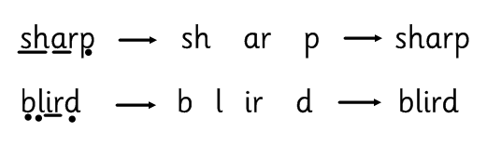

queen | zook
dart | trarm
scream | plote
crate | veem
bright | scrip
sprout | glane
glue | braud
delay | chirt
strike | wheck
grew | prake

