PLEASE NOTE!
Please see QR codes for a range of websites and apps for use at home for half-term and beyond.

White Rose One Minute Maths (Desktop Version)  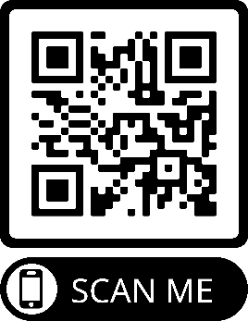  Three word passcode:  tog-jot-nut | White Rose One Minute Maths (App)  Type in ‘One Minute Maths’ or ‘1 Minute Maths’ into your app store on your phone. | BBC Cbeebies Games  Has a range of different games in different subjects for children to play!  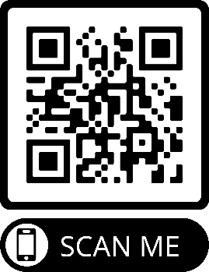
ICT Games  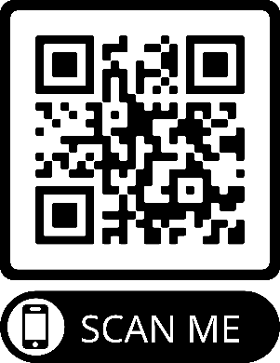  Has a range of Maths and English games for children to play! | Topmarks  Has a range of Maths and English games for children to play!  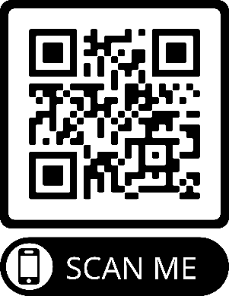 | Phonics Play  Has a range of phonics games the children can play!  