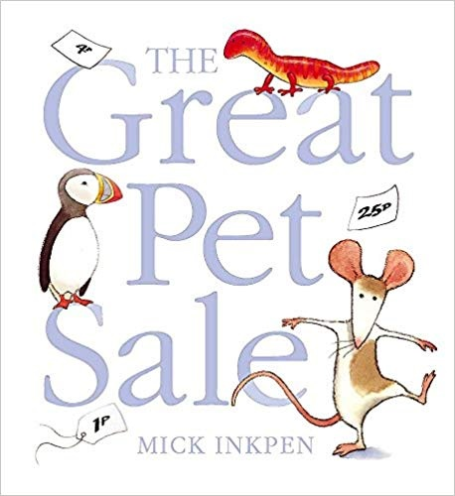
The Great Pet Sale
Maths Activities
First of all set up your own pet shop. You can use any of your cuddly toys or perhaps you could draw your own animals.
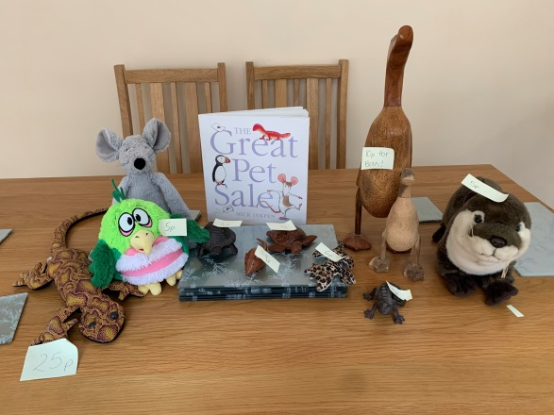
Make some signs to advertise your pet shop. You could even think of your own pet shop name!
This is my pet shop.

Can you spot the rat?

These ideas are for you to use a different times. Don’t try and tackle them all at once.
Foundation 1
- Can you count how many pets are in the pet shop? (Up to 10)
- Use language such as first, second, third, fourth
- Can you sort the different pets into groups for example all of those pets with four legs, wings etc. Talk about which set has more or less.
- Can you write price labels for your animals?
- Can you use coins (1pences) to pay for your animals? The tortoise is 5p-count out 5 one penny coins?
- Put five animals in a line. Get a grown up to hide some of the animals under a towel. Can you guess how many animals are missing from the line?
- Hide one of the pet shop animals in your living room. Can you describe where it is by using words such as next to, above, behind, inside?
Foundation 2
- Count how many pets are in the pet shop (Up to 10).
- Write price labels for your pets- 1p-10p. Remember to get your numbers the right way around. Check with a grown-up.
- Put four animals in a bag-Can you order the price labels from the smallest to the largest amount?
- Order the prices and then ask a grown up to remove an animal from the line. Can you guess which number is missing e.g 1p, 2p, 3p,4p-----6p.
Use your reasoning skills to talk about how you know which number is missing? I know it is 5 because it comes before 6.
- Pay for the pets using 1p and 2p coins.
- Pretend that the animals are not selling. Reduce the price by 1p. What are the new prices in the shop? Re-write the labels.
- Choose two animals from the shop. Can you work out the total price? You may need to use counters (pasta pieces) to help you.
- You have 10p to spend at the pet shop. Can you work out which animals you could buy? How many ways can you spend your 10p?
- Can you order the pets from the shortest to the tallest?
Year 1
- Can you count how many animals are in your pet shop? Can you count them in 1s, 2s and 5s?
- Write price labels for your animals (1p-20p). Remember to get your numbers the right way around.
- Put four animals in a bag-Can you order the price labels from the smallest to the largest amount? If it is a two-digit number such as 12p can you say how many tens and ones in that number?
- Can you sort the pets into prices that are an odd amount and prices that are an even amount?
- Choose an animal from the pet shop and use different coins to pay for the pets.
- Choose two animals from your pet shop to buy each time? Can you work out the total cost of the animals?
- Which pets could you buy which have a total of 10p?
- Work out how much each pet would cost in your shop if prices increased by 1p, 2p, 5p or 10p.
- Work out how many ways you could spend 10p in your pet shop. What about if you had 20p. How many different ways can you answer these problems?
- Choose any pet from the pet shop and then work out how much change you would have from 20p.
- Make a clock for your shop and decide on the opening hours.
Year 2
- Write price labels for your animals (5p-30p). Remember to get your numbers the right way around.
- How many ways can you sort the animal prices for example, odd/even, one digit/two digit, more that 8/less than 8, multiples of 5/not multiples of 5?
- If you double all of the prices-can you work out the new prices?
- Which prices can you halve? Which prices can you quarter? Which prices can you find a third of?
- Practise paying for the animals using different coins. Can you pay for the animals using the fewest coins?
- Choose 3 animals to but from the shop. Can you use an efficient method to add the three numbers e.g. look for bonds to 10, doubles etc.
- How many ways could you spend exactly 20p in your pet shop?
- Choose 2 pets to buy and then work out the change you would receive from 30p.
- Can you work out how much money you would need to buy all of the pets in your shop? Would the cost be greater than £1?
- Find a tape measure or ruler and see if you can order the animals from the shortest to the longest. Remember we use cm to measure.
Can you find the difference between the lengths of 2 animals? For example the tortoise is 12cm and the rabbit is 20cm so the difference is 8cm.
What is the total length of all the animals? Is the length longer, shorter or equal to one metre?
- Make a clock for your pet shop and decide on the opening and closing hours. Can you calculate how long your pet shop will be open each day/week?

Send me some pictures of your pet shops!
headteacher@blackhorsehill-infant.wirral.sch.uk

