Year 1 Homework
Week ending 19.4.24
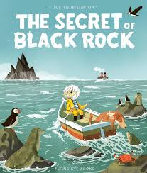

Dear Parents and Carers,

Firstly, welcome back! We hope you all had a lovely Easter break and are ready for an exciting summer term. This week in English, we have begun our new book ‘The Secret of Black Rock’ by Joe Todd-Stanton. We have introduced new vocabulary to the children such as; harbour, looming and jagged. Additionally we have looked at finding nouns in pictures from the text. The children are becoming very familiar with the definition of a noun, as it is a person, place or object. They have used these nouns to come up with different noun phrases, for example, translucent calm sea, jagged rough rocks and small cute puffin.

In Maths, we have started our learning about length and height. We have been using vocabulary such as; longer, shorter, taller, to compare different objects. We have also been using cubes and rulers to find the length of different objects in the classroom.

In Science, we have started our learning about materials. We have sorted different objects into natural and human-made materials and have talked about which material objects are made from.

Thank you for your support,

Mr Hamm and Mrs McLeod

ACTIVITIES

Reading – Read your Big Cat Little Wandle book and Reading for Pleasure book.
Maths – Play Level 1 of the measuring game on the following link https://www.topmarks.co.uk/maths-games/measuring-in-cm

English – CHAT CHALLENGE! Can you create noun phrases from the illustration from The Secret of Black Rock? E.g. spotty small fish, gigantic metal boats, bright clear sky.

Science- Draw objects from around your home and label the material they are made from e.g. kitchen cupboard – wood, tiles in the bathroom – stone.

