**Year 1 Homework**

**Week ending 17th November**

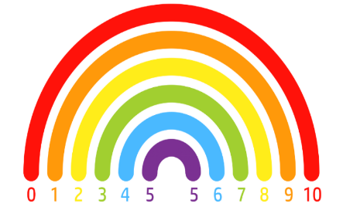

Dear Parents and Carers,

This week in English, we have finished writing our own version of the fairy tale ‘Rapunzel’. Throughout our writing this week we have tried hard to remember our capital letters, full stops, adjectives as well as all the story book language that we have come across over the course of our time focussed on this fiction text.

In Maths this week, we have been continuing our learning about addition. This week we have focused on number bonds for 10 and then we have introduced the children to the systematic method of calculating number bonds. We used ten frames and counters to introduce this and worked practically to develop the children’s fluency. We solved problems and used our reasoning skills to explain.

Thank you for your support,

Mrs McLeod and Mr Hamm

**ACTIVITIES**

1. Reading – Read your Big Cat reading book or your Reading for Pleasure book.
2. English – CHAT CHALLENGE!

Spot the mistakes in the sentences.

The wich had a long pointy. nose

rapunzel wos trapped in a tall robust tower

the witch cut rapunzels long golden Hair.

1. Maths –

Visit the website. <https://www.topmarks.co.uk/maths-games/hit-the-button> select number bonds, then addition within 10. Allow the children to find the answer to the number bond. How many can you score in 1 minute?

1. Geography –

The children have been introduced to aerial maps in Geography. We have drawn an aerial map of our classroom and our school. Can they draw an aerial map of their bedroom?