Black Horse Hill Infant School Long Term Plan Foundation 2
Topic/Theme  Maestro | Me and My Community | Exploring Autumn | Winter Wonderland  Long Ago |  | Starry Night  Signs of Spring | Big Wide World |  | Sunshine and Sunflowers
Half Term | Autumn 1 | Autumn 2 | Spring 1 |  | Spring 2 | Summer 1 | June | Summer 2 | July
English  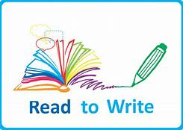 | 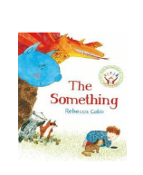  A Finding Story  Recount | 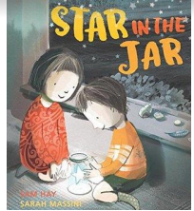  A Finding Story  Information: Poster | 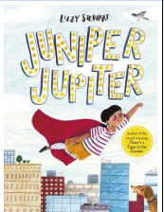  A Superhero Story  Information: A Letter |  | 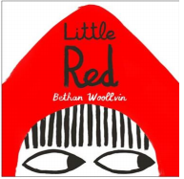  A Traditional Tale  Instructions | 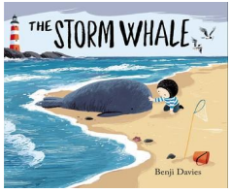  A Friendship Story  Poetry | Healthy Body, Healthy Mind Week | 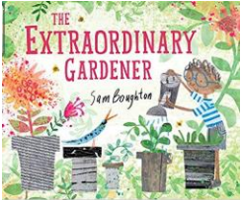  A Transformational Story  Instructions | Coast to Country Environment Project
Phonics | Phase 2 GPCs  s a t p  i n m d  g o c k  ck e u r  h b f l  Tricky words- is, the I | Phase 2 GPCs  f ll ss j as  v w x y z zz qu  words with s /s/ added at the end (hats sits)  ch sh th ng nk  words ending s /z/ (his) and with s /z/ added at the end (bags)  Tricky words- we me be and has his her go no to into she he of | Phase 3 GPCs  ai ee igh oa oo oo ar or ur ow oi ear air er words with double letters: dd mm tt bb rr gg pp ff  longer words  Tricky words-was you they my by all are sure pure |  | Review Phase 3: ai ee igh oa oo ar or ur oo ow oi ear er air  Review all tricky words taught so far  and secure spelling, words with double letters, longer words, words with two or more digraphs, words ending in –ing, compound words  words with s in the middle /z/ s words ending –s words with –es at end /z/ | short vowels CVCC CCVC,short vowels CCVCC CCCVC CCCVCC, longer words, compound words root words ending in: –ing, –ed /t/, –ed /id/ /ed/ –est Tricky words- out today said so have like some come love do words were here little says there when what one |  | long vowel sounds CVCC CCVC CCCVC CCV CCVCC  Review all tricky words taught so far and secure spelling  Phase4 words ending –s /s/ Phase 4 words ending –s /z/ Phase 4 words ending –es, longer words  root word ending in: –ing, –ed /t/, –ed /id/ /ed/, –ed /d/  5 root word ending in: –er, –est longer words
Maths | Pupils will build on previous experiences of  number from their home and nursery  environments, and further develop their subitising, composition  and counting skills. | They will explore the  composition of numbers within 5. They will begin  to compare sets of objects and use the language  of comparison.  Pattern, shape | Pupils will continue to develop their subitising  and counting skills and explore the composition  of numbers within and beyond 5.  . |  | They will  begin to identify when two sets are equal or  unequal and connect two equal groups to  doubles. They will begin to connect quantities to  numerals | Pupils will consolidate their counting skills,  counting to larger numbers and developing a  wider range of counting strategies. |  | They will  secure knowledge of number facts through  varied practice.
PD | Revise and refine fundamental Skills- rolling, crawling, jumping, walking, running, hopping, skipping, climbing.  Develop overall body strength  Develop fine motor skills | Fundamental Skills  Explore and develop the following skills individually, with a partner and as part of a small group: agility, balance, coordination, throwing, catching, jumping and kicking | Gymnastics  Exploring and developing skills, actions and movements in the following areas: travelling, jumping, balancing, rocking and rolling. |  | Gymnastics  Exploring and developing skills, actions and movements in the following areas: travelling, jumping, balancing, rocking and rolling. | Dance Activities  Themed activities linked to the development of controlled movements and actions with changes in speed and direction. |  | Dance Activities  Themed activities linked to the development of controlled movements and actions with changes in speed and direction.  Sports Day
Jigsaw/PSED/SMSC | Being me in my world (Jigsaw) | Celebrating Differences (Jigsaw) | Dreams and Goals (Jigsaw) |  | Healthy me(Jigsaw)  sleep | Relationships (Jigsaw)  Staying safe in the sun |  | Changing me (Jigsaw)
Understanding the World  (Past and Present) | Talk about the lives of the people around them and their roles in society.  Know some similarities and differences between things in the past and now, |  | Arctic explorers from the past  Changes from being a baby. Life in the past Beatrix Potter |  | Famous astronauts  Understand the past through settings, characters and events encountered in books read in class and storytelling. |  |  | Climate change and pollution
Understanding the World  People, Culture and Communities | Describe their immediate environment using knowledge from observation, discussion, stories, non-fiction texts and maps. Learn about the people that form our community e.g school, emergency services | Harvest  Christianity- marriage, Christmas  Diwali | Compare life in our country with the life in other countries.  Christianity- The Bible  Mothering Sunday |  | Famous astronauts  Beatrix Potter  Easter  Baptism  Holi | Islam- Eid |  | Learn about the global community to which they belong and explore how living things, communities and climates differ around the world.
Understanding the World  The Natural World |  | Seasonal changes (autumn), weather, making observations, caring for the environment | Natural changes that occur in winter, explore places that have snow all year round and the animals that live there |  | Nocturnal animals, space and the night sky  Seasonal changes (spring) | Caring for plants and animals in the local environment |  | Explore how living things and climates differ around the world.  Seasonal changes (summer)
Communication and Language | Listen attentively, make comments about what they have heard and ask questions to clarify their understanding. Hold conversation when engaged in back-and-forth exchanges with their teacher and peers. Participate in small group, class and one-to-one discussions, offering their own ideas, using recently introduced vocabulary | Participate in group discussions, learn and use new vocabulary | Articulate ideas in well-formed sentences, engage in non –fiction books, describe events in detail |  | Offer explanations for why things might happen, making use of recently introduced vocabulary from stories, non-fiction, rhymes and poems when appropriate. | Follow 2 part instructions, ask and answer questions, Children express themselves effectively, showing awareness of listeners’ needs |  | Express their ideas and feelings about their experiences using full sentences, including use of past, present and future tenses and making use of conjunctions, with modelling and support from their teacher.
Music (EAD) | Explore making sound with voices and percussion instruments to create different feelings and moods. • Make up new words and actions about different emotions and feelings. • Sing with a sense of pitch, following the shape of the melody with voices. • Mark the beat of the song with actions | Begin to use musical terms (louder/quieter, faster/ slower, higher/lower)  . Sing a tune with ‘stepping’ and ‘leaping’ notes. • Play a steady beat on percussion instruments. | Explore the range and capabilities of voices through  vocal play.  • Develop a sense of beat by performing actions to  music.  • Develop ‘active’ listening skills by recognising the  ‘cuckoo call’ in a piece of music. (so-mi).  • Enjoy moving freely and expressively to music |  | Listen to music and show the beat with actions.  • Sing an action song with changes in speed.  Make up new lyrics and accompanying actions.  • Sing and play a rising and falling melody, following  the shape with voices and on tuned percussion.  • Use appropriate hand actions to mark a changing  pitch.  • Listen to a piece of classical music and respond  through dance. | Develop a song by composing new words and adding  movements and props.  • Sing a song using a call-and-response structure.  • Play a call-and-response phrase comprising a short  stepping tune (C-D-E) and sea effects on percussion  instruments.  • Listen to a range of sea-related pieces of music and  respond with movement  Develop listening skills, identifying dynamics (forte, piano,  crescendo, and diminuendo) across a range of different  musical styles |  | Compose a three-beat body percussion pattern and  perform it to a steady beat.  • Sing a melody in waltz time and perform the actions.  • Play a range of percussion instruments  Invent and perform actions for new verses.  • Sing a song while performing a sequence of dance steps.  • Play a two-note accompaniment, marking the pulse on  tuned or untuned percussion.  • Listen to examples of other folk songs from North America.
Expressive Arts and Design | Take part in simple pretend play. Make imaginative and complex small worlds. Develop their own ideas and decide which materials to use to express them  Drawing, painting, colour mixing, junk modelling | Return to and build on previous learning, refining ideas.  Use and refine artistic effects. Using tools and equipment | Create collaboratively, sharing ideas, resources and skills |  | Drawing with care and accuracy | Exploring artwork made by great artists |  | Safely use and explore a variety of materials, tools and techniques, experimenting with colour, design, texture, form and function.
Enrichment activities | Visit from people who work in the local community  Walk to local church | Autumn hunt  Visit from Hedgehog rescue  Nativity performance for parents  Diwali celebration  Baking for CIN  Making vegetable soup  Rocksteady concert | Winter walk |  | Rocksteady Concert | Summer assembly for parents |  | Trip to Chester Zoo  Rocksteady Concert

